**Impact of Global Warming on Natural SST Variability from CCSM4 and Observations**

Dong-Ping Wang[1], Dake Chen[2]

email: dong-ping.wang@stonybrook.edu

**Abstract**

The global nonseasonal sea surface temperature (SST) pattern is examined from observations and the NCAR Community Climate System Model version 4 (CCSM4) of the fifth phase of the Coupled Model Intercomparison Project (CMIP5). An extended Empirical Orthogonal Function (EEOF) analysis with a sliding window of five seasons is used to obtain the spatio-temporal SST structures. The dominant global SST variability during recent warming is associated with canonical El Nino mode and a growth/decay phase. The canonical mode has a strong cooling trend, but has negligible contribution to the global mean. The growth/decay phase, on the other hand, shows a warming trend that reflects the rising global mean temperature. The warming is not uniform, and in particular, strong warming is found in the North Atlantic at low and high latitudes. Compared to unforced (natural) model run, the observations suggests changes in growth/decay pattern in response to anthropogenic forcing. The forced (historical) model run however does not appear to be capable of simulating observed changes in El Nino behavior. Rather, the six-member model ensemble typically shows a ubiquitous warming everywhere. The failure of climate models to produce observed rapid warming in the North Atlantic could have important policy implication on climate change.

**1. Introduction**

Global sea surface temperatures (SST) from historical ship data and satellite advanced very high resolution radiometer (AVHRR) measurements (since 1982) have shown a gradual warming of Earth's climate in the twentieth century. Figure 1 shows the observed global mean SST with seasonal components removed, based on the UK Met Office Hadley Centre's sea ice and sea surface temperature dataset, HadISST (1870-2012). Also shown is a model global mean SST (1850-2005), forced by observed atmospheric composition changes (reflecting both anthropogenic and natural sources), based on the National Center for Atmospheric Research (NCAR) Community Climate System Model Version 4 (CCSM4) in the fifth phase of the Coupled Model Intercomparison Project (CMIP5) (Taylor et al. 2012). The model and observation have a similar warming trend. They also show comparable interannual (3-8 years) SST variations associated with El Nino. (Since El Nino is a natural variability, the timing of individual events from the model generally would not match observations.) El Nino is the dominant global SST variability, and is controlled by a delicate balance of thermal and dynamic feedbacks between atmosphere and ocean in the tropical Indo-Pacific Ocean. An intriguing question that may arise is whether El Nino might interact with rising global mean temperatures. El Nino and its teleconnections could be modified when the tropical climate evolves under global warming (Collins et al. 2013). Since El Nino has enormous influence on the precipitation and temperature worldwide, any positive feedback might amplify the societal impact of a gradually warming climate. On the other hand, if part of rising global temperatures is attributed to natural variability, the effect of anthropogenic forcing might have been overstated.

El Nino has large natural variability. Model experiments under controlled external forcing have shown large multidecadal modulations of El Nino behavior (Wittenberg 2009; Deser et al. 2012). Since the instrumental record is relatively short, using observations to detect a externally forced change in El Nino behavior would have great difficulty. Indeed, in order to filter out El Nino signals, previous studies often restrict El Nino phenomenon to the tropical Pacific, which in essence, has eliminated possibilities of modified atmospheric teleconnections (Penland and Matrosova, 2006; Thompson et al. 2009; Compo and Sardeshnukh, 2010). An alternative approach is to compare coupled climate model simulations with and without external forcing, a technique used in the Intergovernmental Panel on Climate Change (IPCC) reports. With a large model ensemble of varying initializations and physics, the natural variability could in principle be suppressed. On the other hand, while coupled climate models are capable of producing basic El Nino pattern, it is not clear if they could also simulate externally forced changes, considering the sensitivity of various feedback mechanisms.

In this study, we use both observations (HadISST) and model (CCSM4) to determine the spatio-temporal patterns of global SST variability. We compare differences in SST patterns between unforced ('natural') and forced ('historical') model runs. We also compare differences between unforced model run and observations. This allows to identify externally forced changes in El Nino behavior from observations and model (Meehl et al. 2009). The analysis is focused on recent warming since the 1980s when AVHRR-based global SST measurement is available. Although, the early warming and the interim period are also briefly examined. We choose to treat each climate 'regime' separately, because the characteristics of global ST pattern might not remain invariant in a changing climate. There is also concern about data quality prior to the satellite era. The rest of the paper is structured as follows. Section 2 provides a description of model and observations and the analysis method. Section 3 describes the spatio-temporal patterns of global SST from model and observations. Section 4 summarizes the results and discusses outstanding issues with regard to separating natural variability from external forcing.

**2. Data and Methods**

*a. Data*

We use the UK Met Office Hadley Centre's sea ice and sea surface temperature dataset, HadISST, a 1o × 1o high-resolution SST dataset reconstructed from in situ and satellite observations (Rayner et al. 2003). Seasonal means are computed from monthly data, and SST anomalies are formed by removing seasonal cycle, the mean of each season. The gridded SSTs are area weighted by the square root of the cosine of latitude (North 1982). The analysis is over the globe between 70oS and 70oN, retaining the original data resolution. For model data, monthly averaged SST from CCSM4 are obtained for historical (1850-2005) and natural (1850-1998) runs in CMIP5. The historical run includes both natural causes such as volcanic eruptions, and anthropogenic activities, such as fossil fuel burning. We also use the National Centers for Environmental Prediction/National Center for Atmospheric Research (NCEP/NCAR) Reanalysis (2.5o × 2.5o) for sea level pressure (SLP) and surface wind (Kalnay et al. 1996). The atmospheric data are used only to confirm the results from previous studies which may have used different time period or spatial domain. We do not show results involving atmospheric data.

*b. Methods*

An extended empirical orthogonal function analysis (EEOF) is used in this study. The EEOF is the same as EOF or Principal Component Analysis (PCA), except that the original and its time-lagged fields are concatenated to form an extended dataset. This allows spatial patterns to evolve with time to capture the spatio-temporal variations. We use a sliding window of 5 seasons for EEOF. The results are similar with a 7-season window. Guan and Nigum (2008) have applied EEOF to study the SST variability. Their analysis includes entire historical dataset (1870 onward), but is restricted to 2/3 of the Pacific basin (20oS - 60oN) with degraded resolution (5o × 2.5o).

The extended dataset is large. For a 30-year record, there are 120 images (seasons) of 360 (longitudes) × 700 (latitudes × lags) pixels each. In EOF, the two-dimensional image is converted to a vector, resulting in a very high-dimensional data. For computational efficiency, a two-dimensional PCA, the Generalized Low Rank Approximation of Matrices (GLRAM), is adopted in this study (Ye 2005). The spatial data, such as SST or SLP anomalies, are highly organized (spatially coherent). Therefore, it is feasible to reduce data dimension significantly while maintaining data fidelity. In a two-dimensional PCA, the mean square error (MSE) between original and transformed data matrix is minimized

 (1)

A*i* (r *× c*), , is an image where *r* and *c* denote the number of rows and columns respectively, and *n* is the total number of images. The inner summation is over all matrix elements. In (1), a pair of linear transformations, L (*r × la*) and R (*lb × c*), with orthonomal columns, is sought such that A*i* is projected in a least squares sense onto M*i* (*la × lb*) of a reduced (low) rank, (*la* and *lb*) « (*r* or *c*). In our case, (*la* , *lb*) = (60, 30), leading to more than100-fold dimension reduction from A*i* to M*i*. Then, EOF is applied to the transformed dataset M*i*, , to obtain a set of principal components. Since M*i* is a small fraction of A*i*, GLRAM is much more efficient than applying EOF directly to the original dataset. The two methods give virtually identical results.

**3. Results**

*a. CCSM4*

The historical run shows a gradual rise of global mean temperatures (Fig. 1). There are two periods of sustained temperature rise: a recent warming since 1960, and a brief warming at the beginning of the century. We note that warming trends in model global mean temperature are offset from observations by 10-15 years. Nevertheless, since the model is a controlled experiment, the impact of external forcing can be examined by comparing between forced and unforced runs independent of observations. We focus on a 40-year period from 1960 to 2000 of the recent warming. We first consider the natural run. The global mean temperatures are flat in the natural run (not shown). The first two EEOF modes account for 21 and 14% of total variance respectively. Figure 2 shows corresponding global SST patterns. Both modes are clearly associated with El Nino. Mode 1 shows the canonical El Nino (warm event) pattern of large warming in the tropical central-eastern Pacific surrounded by a 'horse-shoe' cooling pattern spanning from the tropical western Pacific to the mid-latitudes in both hemispheres. The 5-season sequence spans from JJA0 to JJA1. (The first year of a warm event is denoted by a zero year.) The warming peaks in SON0 and DJF1 in the tropical Pacific, but is delayed by a season or two (MAM1) in the tropical North Atlantic, western Indian Ocean, and the Southern Ocean. Mode 1 is almost stationary, and is basically the same as the leading EOF mode, a common definition of the canonical El Nino mode.

Mode 2, which leads Mode 1 by about 3 seasons, is the growth phase of El Nino, marked by transition from cold to warm anomalies in the tropical eastern Pacific. (The opposite polarity of Mode 2 describes the decay phase.) There is also a persistent warm band in the central North Pacific (~ 40oN), associated with a weakening Aleutian low during a cold event (Alexander et al. 2002). The Nino-3.4 index, the area averaged SST anomalies in the equatorial Pacific, 5oS-5oN, 170o-120oW is a common definition of El Nino variability. Also, the cold tongue index (CT), which extends the area coverage to the coast of South America, 6oS-6oN, 180o-90oW, is a better measure of total tropical Pacific variability (Zhang et al. 1997). The first two modes explain 89.0 and 7.3% of Nino-3.4 variance respectively. In terms of CT, the percentage variance explained are 89.4 and 8.5% respectively. Using either measure, the first two modes account for nearly all El Nino variability. Mode 1 defines the general El Nino pattern, while Mode 2 allows for variations of individual events.

To see how unforced global SST patterns are modified by anthropogenic forcing, we repeat the same calculations with a historical run of the same period (1960-2000). Recalling that the mean global temperature increases substantially during this period (Fig. 1). Figure 3 shows SST patterns of the first three EEOF modes, which account for 21.4, 12.4 and 11.3% of total variance respectively. The first two modes are similar to the corresponding unforced modes. However, there are some changes. For example, in Mode 1, warm anomalies are enhanced in the Gulf of Alaska and Southern Ocean, and in Mode 2, warm anomalies become stronger in the central North Pacific. Mode 3, on the other hand, shows a ubiquitous warming everywhere except at the eastern tropical Pacific where a trace of decay phase can be noted.

Figure 4 shows principal components (PCs) of the first three EEOF modes together with Nino-3.4. The first three modes account for most of CT variance; the percentage error variance is 8.4, 6.0, and 2.6 %, with one, two, and three modes respectively. On the other hand, while there is no apparent trend in Nino-3.4, both Modes 1 and 3 have a warming trend. To examine if the global temperature rise is associated with Modes 1 and 3, we compare model global mean temperature with that reconstructed from the first three modes (not shown). The agreement is excellent; the variance explained is 36.8, 43.9, and 98.8% with one, two and three modes respectively. There are two types of response that contribute to a global warming trend. Mode 3 of a widespread warming is the most dominant, explaining about 55% of the variance and 2/3 of the linear trend. It is basically a secular mode. In contrast, Mode 1 is an outstanding example in which a natural mode of variability interacts with external forcing (Solomon et al. 2010). As the canonical mode is highly correlated with east-west SLP variability, a warming canonical mode is consistent with a weakening Walker circulation in response to global warming (Held and Soden 2006; DiNezio et al. 2013).

*b. Model ensemble*

The CCSM4 historical run includes 6 realizations of different initial conditions. The global mean temperatures are essentially the same in all 6 runs. Thus, despite a small ensemble, the model's internal variability does not appear to impact the warming trend. However, there are significant variations in the warming pattern. We illustrate with the recent warming period (1960-2000). Table 1 shows the percentage variance of global mean temperatures accounted for with one, two, and three modes respectively. Run 2 is the base case. In Runs 1, 2, 5 and 6, the secular mode (Mode 3) of a widespread warming is dominant. In Runs 3 and 4, on the other hand, the modified canonical mode (Mode 1) is most important. It is not clear why there is such a large spread. In all cases though, the overall effect is a widespread warming.

*c. Observations*

In observations, the recent warming started in the mid-1970s. We choose a 30-year period of the satellite era, 1982-2012. Figure 5 shows the first three EEOF modes, which explain 22.3, 12.7, and 9.1% of total variance respectively. Mode 1 shows the canonical pattern of warming in the central-eastern equatorial Pacific and cooling in the extratropics. Mode 2 is lagged by about 3 seasons from Mode 3, and together they constitute an entire growth/decay phase of 7 seasons. The sequence begins in DJF0 with cold anomalies in the equatorial central-eastern Pacific and warm anomalies at midlatitudes in the North and South Pacific. We note that the warm and cold anomalies have comparable amplitudes, a feature commonly attributed to the Pacific Decadal Oscillation (Zhang et al. 1997). By JJA0, cold anomalies at the equatorial Pacific have transitioned to a warm event, while warm anomalies in the South Pacific have diminished. The warm anomalies in the central North Pacific, on the other hand, linger through DJF1. The warm event eventually transitions to a cold event in JJA1, completing the growth/decay phase.

In the North Atlantic at high and low latitudes, strong warming is persistent through the growth/decay phase. It peaks in DJF1/MAM1, a delay by 1-2 seasons from the warm event in the equatorial Pacific. In the tropical Indian Ocean, warming begins in the west while it is still cooling in the east, an example of the Indian Ocean Dipole (IDO) (Saji et al. 1999). In this case, the IDO is part of the global pattern. The Indian Ocean warming peaks in DJF1, and is gradually diminished in JJA1. The delayed warming in North Atlantic and Indian Oceans also can be seen in the composite of historical El Nino events (Harrison and Larkin 1998; Deser et al. 2010). However, because the SST pattern is not stationary, temperature anomalies in the composite are much weaker than in EEOF modes.

Figure 6 shows principal components of the first three modes; Nino-3.4 is included for reference. The strong warm events of 1982/1983 and 1988/1989 are clearly marked in Nino-3.4. Mode 1 is highly correlated with Nino-3.4 (γ = 0.86). Modes 2 and 3 are also correlated with Nino-3.4 with time lags of 2 (γ = 0.62) and -1 (γ = 0.50) seasons respectively. The first three modes account for most of tropical SST variability, about 99% of CT. Nino-3.4 has no apparent trend in the past three decades. In contrast, Mode 1 has cooled substantially with a negative slope of -0.049±0.020 per year for standardized PC1 (at 95% confidence interval using a Student *t*-test). In other words, PC1 has dropped by 1.5 standard deviations in 30 years. Modes 2 and 3, on the other hand, have become warmer with significant positive slopes of 0.044±0.021 and 0.084±0.016 respectively for standardized PC2 and PC3. To find out how much of global temperature rise is attributed to the first three modes, Figure 7 compares observed and reconstructed global mean temperatures (averaged over 5 seasons). The variance explained is 3.4, 43.5, and 92.1% respectively with one, two and three modes. In other words, the global warming trend almost entirely resides in the growth/decay phase of El Nino. The warming is not spatially uniform with the largest contribution from the North Atlantic and central North Pacific. The canonical mode, on the other hand, is negligible, despite its strong cooling trend, as warm and cold anomalies in the Pacific tend to cancel each other.

*d. Early warming period*

The anthropogenic forcing is cumulative as the greenhouse gases increases continuously. Also, there could be significant multidecadal natural variability. This suggests that the global SST response to external forcing might evolve continuously. We repeat the same calculations for the early warming period, 1910-1940. We focus on the observations only. Figure 8 shows the first three EEOF modes, which explain 23.3, 13.2, and 9.4% of total variance respectively. The spatial patterns are similar to the recent warming period. For example, strong warming in the North Atlantic remains an outstanding feature in the growth/decay phase. The North Pacific warming though apparently is absent, and part of North Atlantic warming is incorporated in the canonical mode. For global mean temperatures, the variance explained is 37.9, 87.0, and 94.7% respectively with one, two and three modes. The growth/decay phase is most important, contributing about 60% of the variance and 3/4 of the slope. We note that the differences of EEOF modes between the early and recent warming periods could simply be due to data quality. The pre-satellite SST data are built from sparse ship observations of irregular spatio-temporal coverage. During the early warming period, for example, only the North Atlantic has a complete spatial coverage, and the temporal coverage is worse (Solomon et al. 2011).

To explore whether SST patterns remain invariant in a changing climate, we also compute EEOF modes of the interim period, 1945-1975, when global mean temperatures are flat (Fig. 1). The first two modes correspond to the canonical mode and decay phase respectively. They resemble the unforced El Nino pattern. Mode 3, on the other hand, is quite different from those found in the two warming periods. It shows a dipole pattern in the Atlantic Ocean, with a cooling trend in the North Atlantic and a warming trend in the South Atlantic (not shown). The warm and cold anomalies cancel each other, resulting in little change in the global mean. The fact that the SST patterns vary greatly from one regime to the other, whether the variations are real or artificial, has important practical implication for data analysis. Application of PCA or any other objective methods indiscriminately to the entire twentieth century SST record is surely to produce contaminated results (Messie and Chavez 2011).

**4. Discussion**

The question of whether El Nino might respond and feedback to anthropogenic forcing is examined by comparing model and observed global SST patterns during the recent warming period. Using unforced model run as a reference, the canonical mode appears to be little affected by external forcing. The growth/decay mode, on the other hand, is significantly modified, showing strong temperature anomalies in the North Atlantic and central North Pacific. The corresponding principal components indicate a warming trend that accounts for observed global mean temperature rise. This suggests a dominant role of El Nino and teleconnections in global change. For comparison, climate model reproduces the canonical pattern, and warming in the central North Pacific and Indian Ocean during the growth/decay phase. The model however fails to produce the observed warming trend in the North Atlantic. This suggests that CCSM4 is not capable of simulating changes in El Nino behavior in response to global warming.

In the model, the canonical mode shows a warming trend in response to external forcing. The observations, on the other hand, indicate a strong cooling trend, which nevertheless is consistent with a strengthening of Walker circulation in the past three decades (McPhaden et al. 2011; L'Heureux et al. 2013). Since the pattern of canonical mode does not appear to be affected by external forcing, the cooling trend might be a natural cycle, a mega-ENSO identified from decadal changes in Northern Hemisphere summer monsoon (Wang et al. 2013). From the global perspective, cooling in the tropical Pacific is compensated by warming in midlatitudes, and the cooling trend has little effect on global mean temperature. However, as the cooling deepens, the canonical mode has a diminishing role in warm events (Fig. 6). This coincides with the apparent disappearance of eastern-Pacific (EP) type El Nino since the 2000s (Asohk et al. 2007; Kug et al. 2009).

It is well known that the North Atlantic SST are dominated by multidecadal internal variability, the Atlantic Multidecadal Oscillation (AMO) (Delworth and Mann, 2000; Knight 2009). A commonly used index is the AMO index, the North Atlantic mean temperature minus the global mean (Trenberth and Shea, 2006; Ting et al. 2009; Deser et al. 2012). (The model-derived North Atlantic mean temperature is basically the same as the observed global mean temperature.) However, global warming is not uniform, and subtracting a global mean does not completely remove contribution from external forcing. To see how much of the North Atlantic warming is due to global SST pattern, we compare observed North Atlantic mean temperature (averaged over 5 seasons) with that reconstructed from the first three global EEOF modes (Fig. 7). The two time series are very similar; the variance explained is 13.0, 49.8, and 88.4% of total variance with one, two, and three modes respectively. In other words, rapid warming (about 3× the global mean) in the North Atlantic is merely a spectacular display of a warming climate. (This is also the case during the early warming period.) If we assume, as has been done through this study, that the rising global temperature is due to anthropogenic forcing, there won't be much room left for natural variability.

The failure of climate models to produce observed warming in the North Atlantic leads to two possibilities. On one hand, observed warming trend in the past three decades could be due to anthropogenic forcing, but the model is not producing a proper warming pattern. This would suggest that climate models might have severely underestimated the potential impact of global warming in the North Atlantic. On the other hand, observed warming trend could be due to a natural cycle of El Nino teleconnections, manifest in rapid warming in the North Atlantic. This would suggest that climate models might have grossly overstated the impact of anthropogenic forcing. In either case, there will be enormous policy implication on climate change. Significant advance in understanding atmospheric teleconnections is essential in making credible predictions of future climate change.

**Acknowledgements**

We wish to thank I-I. Lin of National Taiwan University for introducing the face recognition method in computer science.

Table 1. Percentage variance explained of global mean temperature in the recent warming period, including one, two, and three EEOF modes.

|  |  |  |  |
| --- | --- | --- | --- |
|  | Mode 1 | Mode 1+2 | Mode 1+2+3 |
| Run 1 | 2.8 | 18.3 | 97.2 |
| Run 2 | 36.8 | 43.9 | 98.8 |
| Run 3 | 64.3 | 97.2 | 97.8 |
| Run 4 | 86.5 | 98.9 | 98.9 |
| Run 5 | 29.7 | 41.4 | 99.0 |
| Run 6 | 9.8 | 10.7 | 99.1 |

**References**

Ashok, K., S. K. Behera, S. A. Rao, H. Weng, and Yamagata, T, 2007: El Nino Modoki and its possible teleconnection. *J. Geophys. Res*., **112**, C11007.

Alexander, M. A. and Coauthors, 2002: The Atmospheric Bridge: The influence of ENSO teleconnections on air-sea interaction over the global oceans. *J. Climate,* **15**, 2205-2231.

Collins, M., and Coauthors, 2010; The impact of global warming on the tropical Pacific Ocean and El Nino. *Nature Geo*., **3**, 391-397.

Compo, G., and P.D. Sardeshnukh, 2010: Removing ENSO-related variations from the climate record. *J. Climate,* **23**, 1957-1978.

Delworth T, Mann M. E., 2000: Observed and simulated multidecadal variability in the Northern Hemisphere. *Climate Dyn.* **16**:661–76

Deser, C., M. A. Alexander, S.-P. Xie, and A. S. Phillips, 2010: Sea surface temperature variability: Patterns and mechanisms. *Annu. Rev. Mar. Sci.*, **2**, 115–143.

Deser C. and Coauthors, 2012: ENSO and Pacific Decadal variability in the Community Climate System Model version 4. *J. Climate,* **25**, 2622-2651.

DiNezio, P.N., G.A. Vecchi, and A.C. Clement, 2013: Detectability of changes in the Walker circulation in response to global warming. *J. Climate*, 4038-4048.

Guan, B. & Nigam, S, 2008: Pacific sea surface temperatures in the twentieth century: An evolution-centric analysis of variability and trend. *J. Climate*, **21**, 2790-2809.

Harrison D. E, and Larkin N. K., 1998: El Nino-Southern Oscillation sea surface temperature and wind anomalies, 1946–1993. *Rev. Geophys.,* **36**, 353–399.

Held, I. M., and B. J. Soden, 2006: Robust responses of the hydrological cycle to global warming. *J. Climate*, **19**, 5686–5699.

Kalnay, E., and Coauthors, 1996: The NCEP/NCAR 40-Year Reanalysis Project. *Bull. Amer. Meteor. Soc.,* **77,** 437–471.

Knight, J.R., 2009: The Atlantic Multidecadal Oscillation inferred from the forced climate response in coupled general circulation models. *J. Climate*, **22**, 1610-1625.

L'Heureux, M.L., S. Lee, and Lyon, B., 2013: Recent multidecadal strengthening of the Walker circulation across the tropical Pacific. *Nature Climate Change*, 1-6.

McPhaden, M. J., T. Lee, and McClurg, D., 2011: El Nino and its relationship to changing background conditions in the tropical Pacific Ocean. *Geophys. Res. Lett*., **38,** L15709.

Meehl, G. A., A. Hu, and B. D. Santer, 2009: The mid-1970s climate shift in the Pacific and the relative roles of forced versus inherent decadal variability. *J. Climate,* **22,** 780–792.

Messie, M. and Chavez, F., 2011: Global modes of sea surface temperature variability in relation to regional climate indices. *J. Climate,* **24**:4314-4331.

Nagura, M. and Konda, M., 2007: The seasonal development of an SST anomaly in the Indian Ocean and its relationship to ENSO. *J. Clim*ate, **20**, 38-52.

North, G. R., T. L. Bell, and Cahalan, R. F., 1982: Sampling errors in the estimation of empirical orthogonal function. *Mon. Wea.* *Rev.,* **110,** 669–706.

Penland, C. & Matrosova, L., 2006: Studies of El Nino and interdecadal variability in tropical sea surface temperatures using a nonnormal filter. *J. Clim*ate, **19**, 5796-5815.

Rayner, N. A., and Coauthors, 2003: Global analyses of sea surface temperature, sea ice, and night marine air temperature since the late nineteenth century. *J. Geophys. Res*., **108**, 4407, doi:10.1029/2002JD002670.

Solomon, A., and Coauthors, 2011: Decadal Predictability Working Group, Distinguishing the roles of natural and anthropogenically forced decadal climate variability: Implications for prediction? *Bull. Am. Meteorol. Soc*. **92**, 141-156.

Taylor, K., R.J. Stouffer, and G.A. Meehl, 2012: An overview of CMIP5 and the experimental design. *Bull. Amer. Meteor. Soc.,* **93**, 485-498.

Thompson, D. W. J., Wallace, J. M., Jones, P. D. & Kennedy, J. J., 2009: Identifying signatures of natural climate variability in time series of global-mean surface temperature: Methodology and insights. *J. Clim*ate, **22**, 6120-6141.

Trenberth, K. E., and D. J. Shea, 2006: Atlantic hurricanes and natural variability in 2005. Geophys. Res. Lett., 33, L12704, doi:10.1029/2006GL026894.

Wang, B., and Coauthors, 2013: Northern hemisphere summer monsoon intensified by mega-El Nino/southern oscillation and Atlantic multidecadal oscillation. *Proc. Nat. Aca. Sci*.

Ye, J., 2005: Generalized low rank approximations of matrices. *Machine Learning*, **61**, 167-191.

**Figure legends**

Figure 1. Global mean sea surface temperature anomalies from observations (blue) and CCSM4 historical run (red).

Figure 2. Spatial patterns of the first two EEOF modes from CCSM4 natural run. Each mode spans five seasons.

Figure 3. Spatial patterns of the first three EEOF modes from CCSM4 historical run. Each mode spans five seasons.

Figure 4. Nino-3.4 index (oC) and principal components (PCs) of the first three EEOF modes from CCSM4 historical run. The PCs have arbitrary scale.

Figure 5. Spatial patterns of the first three EEOF modes from observations. Each mode spans five seasons.

Figure 6. Nino-3.4 index (oC) and principal components (PCs) of the first three EEOF modes from observations during the recent warming. The PCs have arbitrary scale.

Figure 7. (left) Global mean sea surface temperature anomalies from observations (red) and reconstructed from first three EEOF modes (blue); (right) North Atlantic mean sea surface temperature anomalies from observations (red), reconstructed from first three EEOF modes (blue), and AMO index (blue dotted).

Figure 8. Spatial patterns of the first three EEOF modes from observations during the early warming. Each mode spans five seasons.

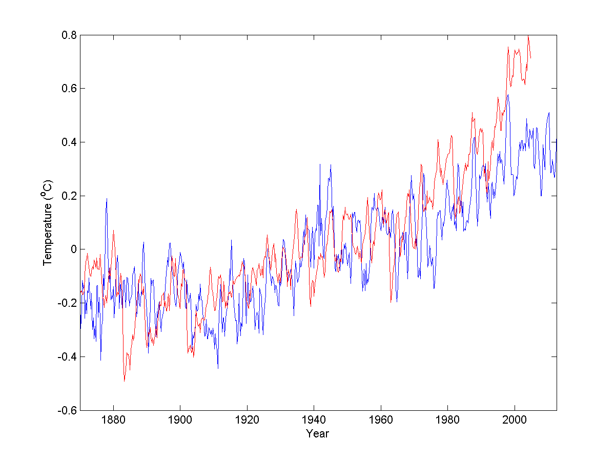

Figure 1. Global mean sea surface temperature anomalies from observations (blue) and CCSM4 historical run (red).

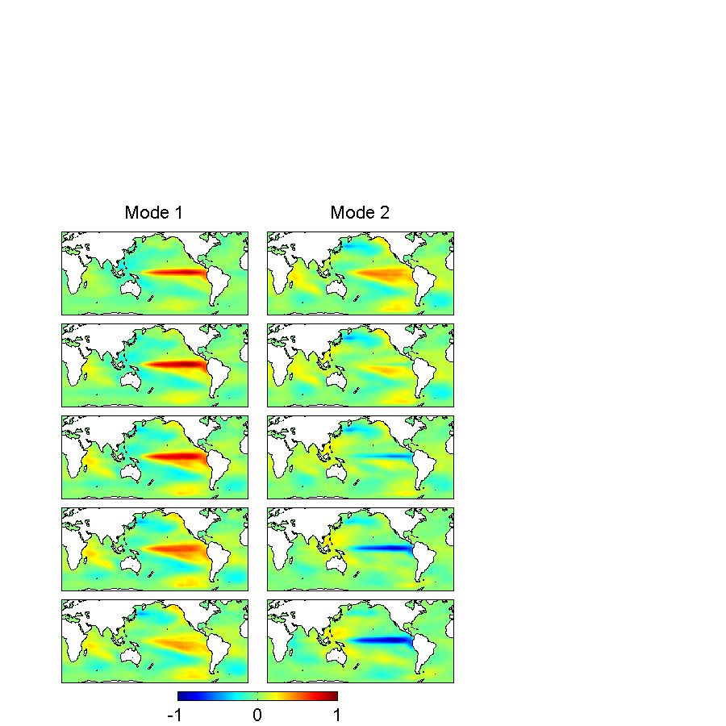

Figure 2. Spatial patterns of the first two EEOF modes from CCSM4 natural run. Each mode spans five seasons.

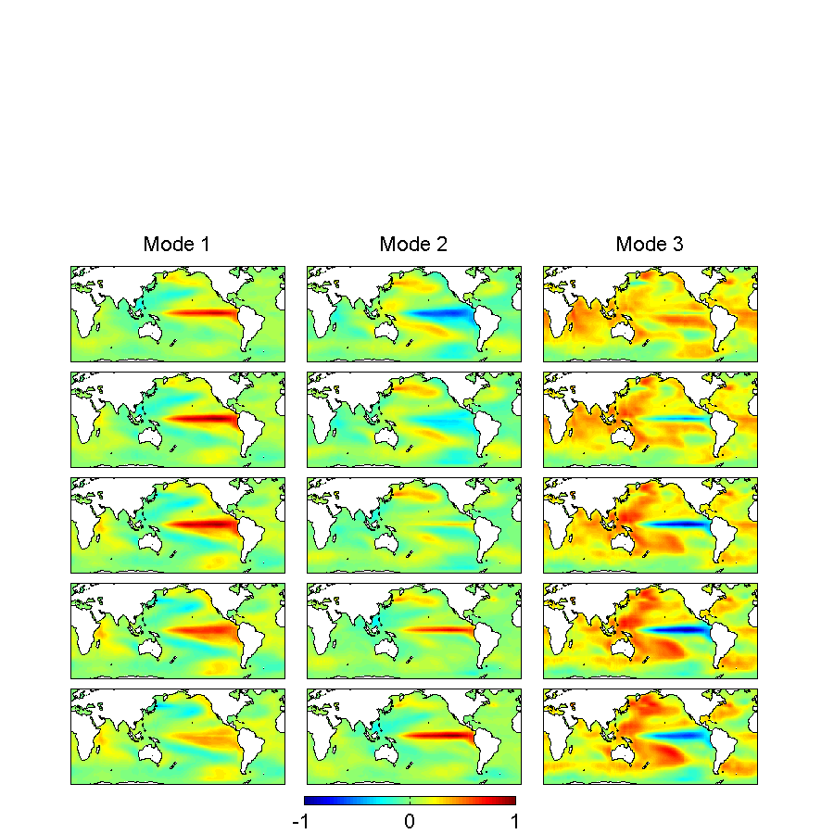

Figure 3. Spatial patterns of the first three EEOF modes from CCSM4 historical run. Each mode spans five seasons.

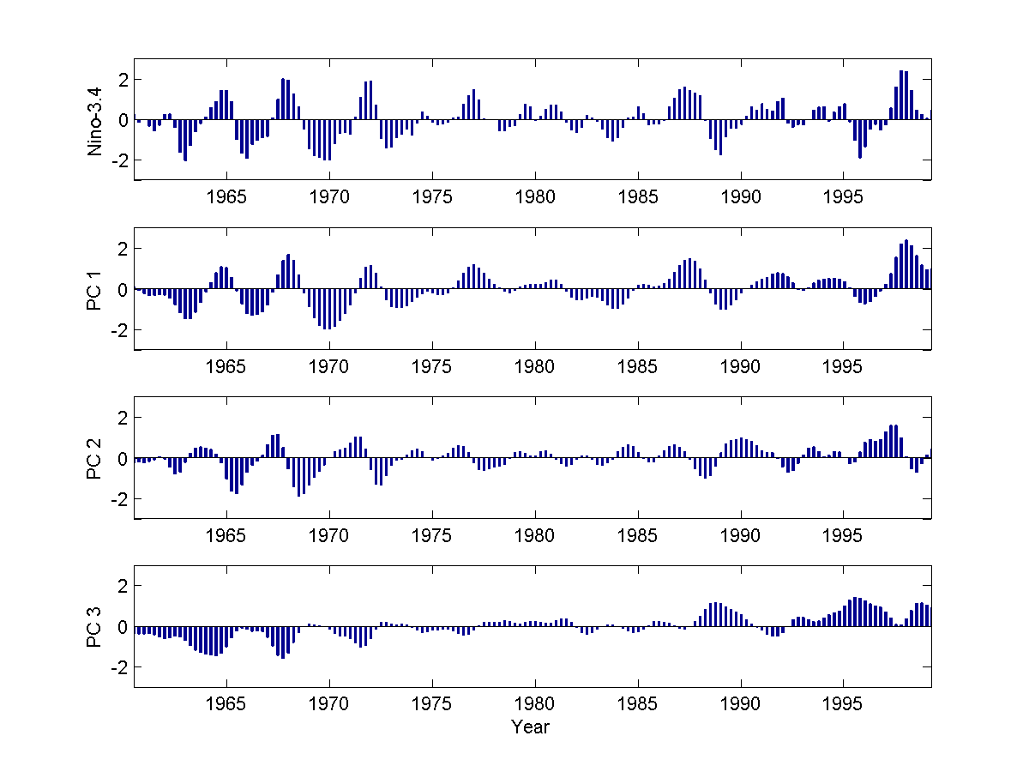

Figure 4. Nino-3.4 index (oC) and principal components (PCs) of the first three EEOF modes from CCSM4 historical run. The PCs have arbitrary scale.

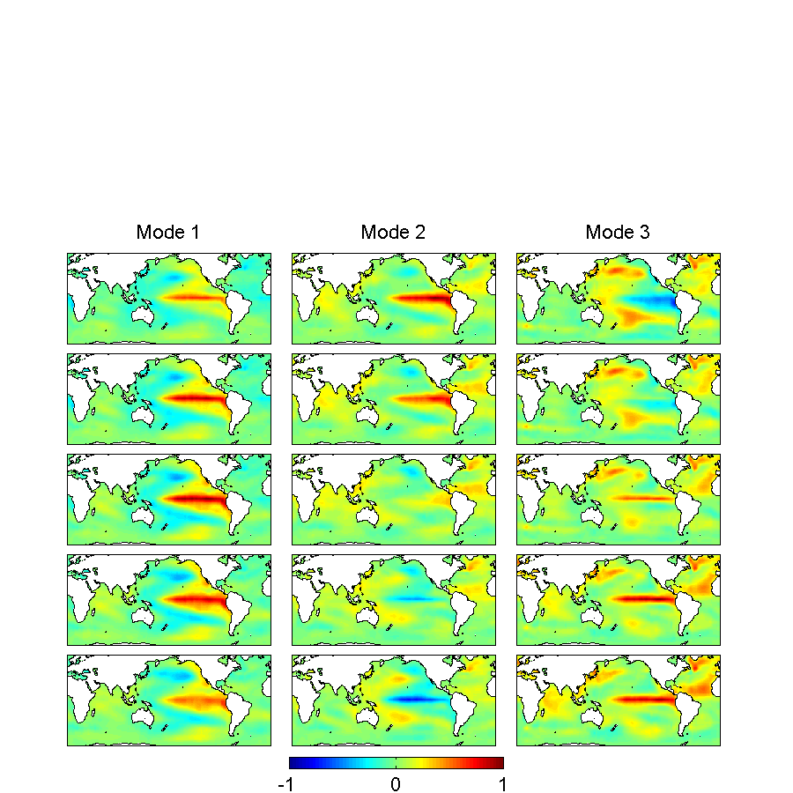

Figure 5. Spatial patterns of the first three EEOF modes from observations during the recent warming. Each mode spans five seasons.

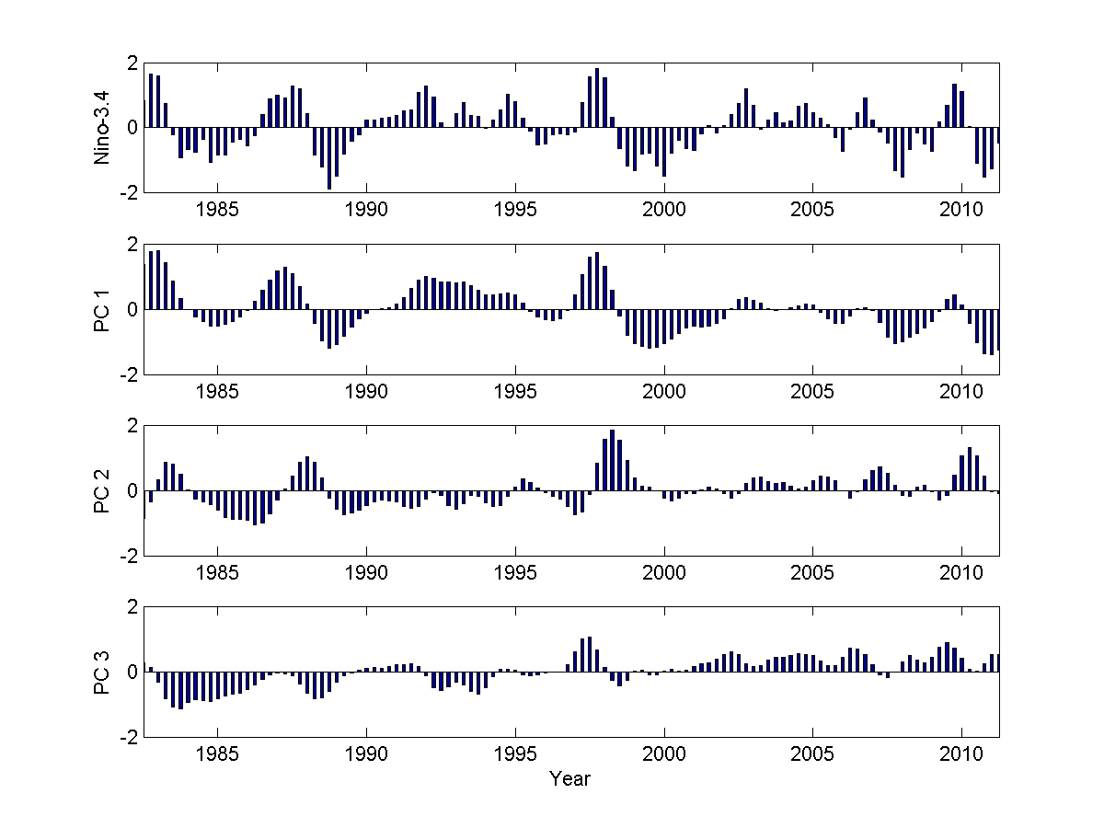

Figure 6. Nino-3.4 index (oC) and principal components (PCs) of the first three EEOF modes from observations. The PCs have arbitrary scale.

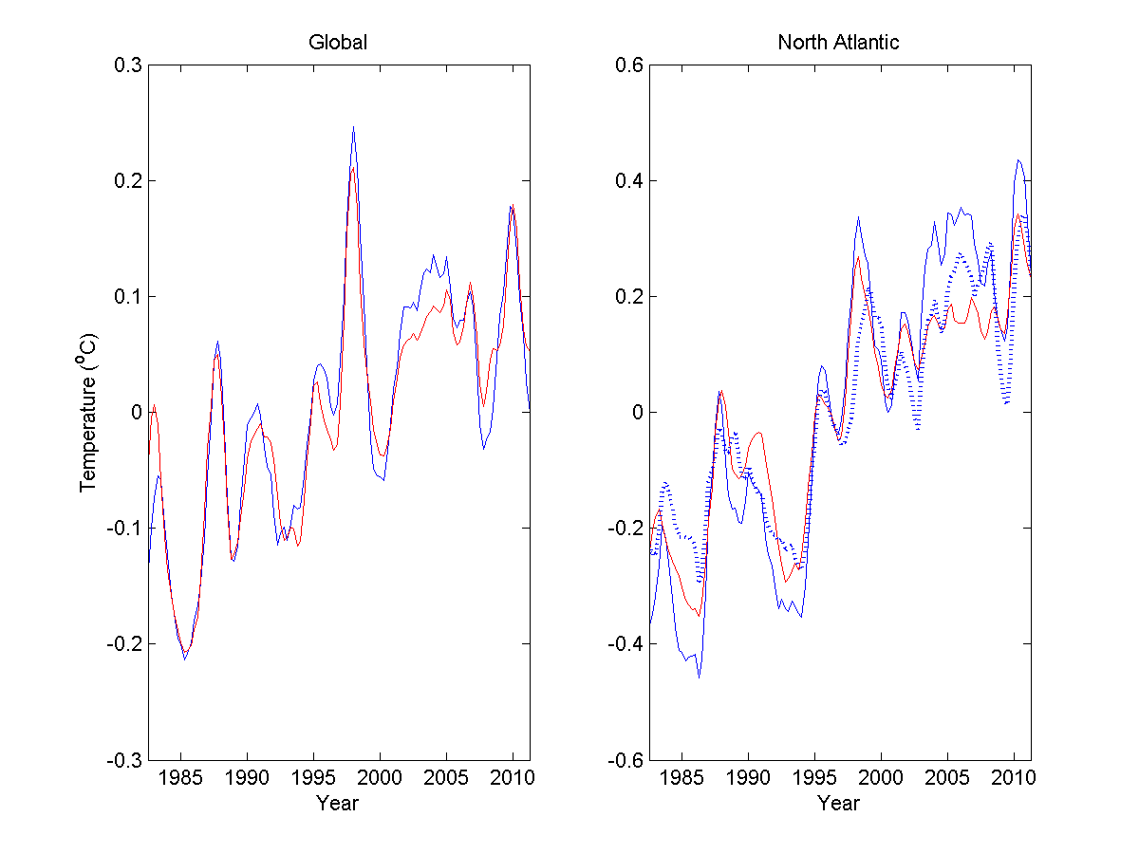

Figure 7. (left) Global mean sea surface temperature anomalies from observations (red) and reconstructed from first three EEOF modes (blue); (right) North Atlantic mean sea surface temperature anomalies from observations (red), reconstructed from first three EEOF modes (blue), and AMO index (blue dotted).

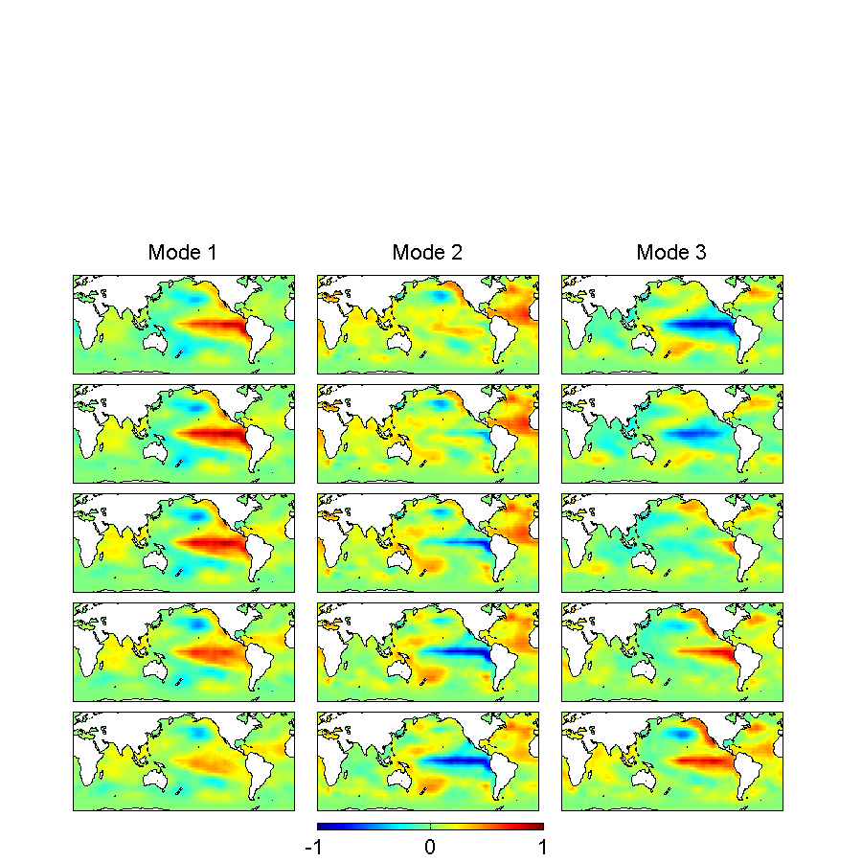

Figure 8. Spatial patterns of the first three EEOF modes from observations during the early warming. Each mode spans five seasons.

1. School of Marine and Atmospheric Sciences, Stony Brook University, Stony Brook, NY
2. State Key Laboratory of Satellite Ocean Environmental Dynamics